Supplementary Material
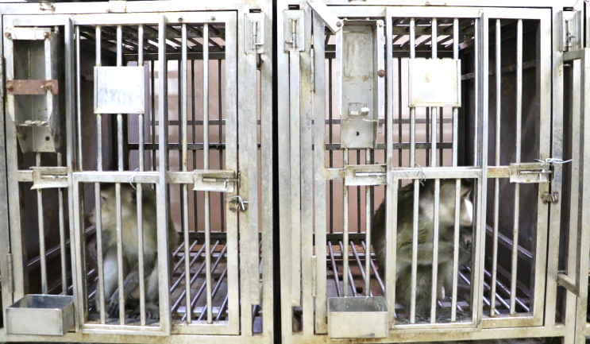
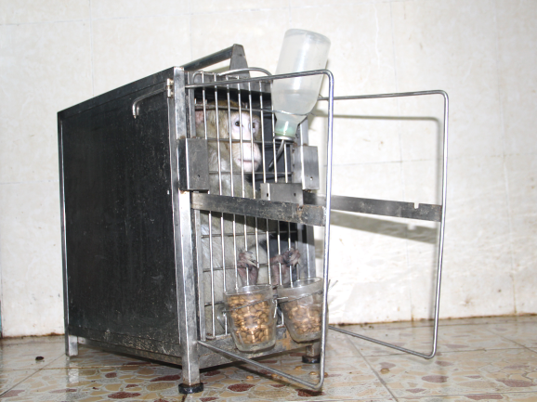
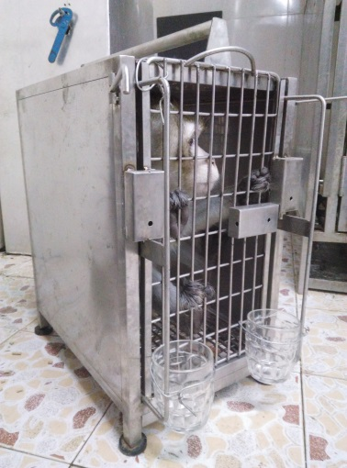
a
c
b
Figure S1 Cynomolgus monkeys living environment.
(a) Primitive Standard size single cage (about 160*120*120cm³) environment inhabited by cynomolgus monkeys.
(b) Stainless steel cages (about 42*30*50cm³) environment inhabited by cynomolgus monkeys for social isolation.
(c) Social isolation+ restraint environment (Its space is 2/5 of the original small stainless steel cage space).

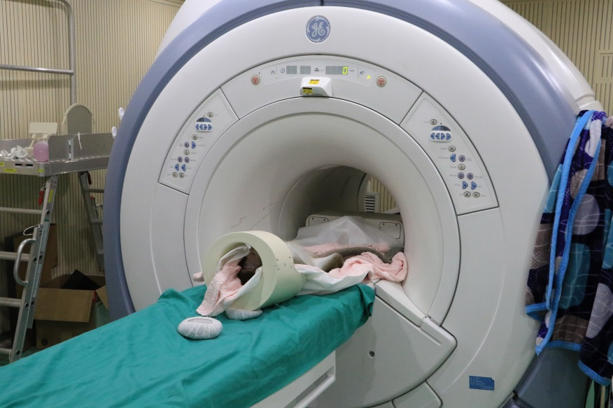
Figure S2 Cynomolgus monkeys brain functional magnetic resonance scanning environment. 3.0T HDXT scanner (GE, USA) equipped with an 8-channel animal head coil for the resting-state fMRI scanning.

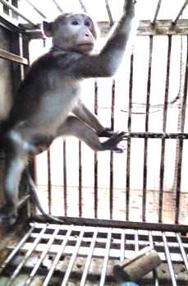
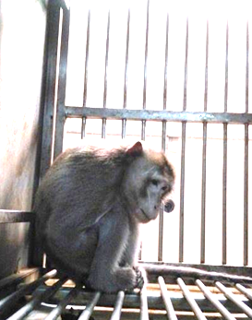
Figure S3 Effect of PDP on behavior of cynomolgus monkeys.
a
b
Normal control cynomolgus
PDP cynomolgus
(a) Normal control cynomolgus monkey behavior.
(b) PDP cynomolgus monkeys exhibit depressive-like behavior, a slumped or collapsed body posture (head lower than shoulders).

Table S1. Schedule of Promote Depressive Procedure（PDP）
Day | Food deprivation | Water deprivation | Overnight illumination | All day light deprivation | Ice-water | Social isolation | Restraint | Stick stimulation | Stick cage | Cage dystopia
Monday | 7:30 |  |  |  | 7:30-7:40  12:00-12:10  19:30-19:40 | All day | 7:30  17:30 | 7:50-7:55  12:20-12:25  19:50-19:55
Tuesday | 7:30 | 7:30 |  |  |  | All day | 21:00 | 7:50-7:55  12:20-12:25  19:50-19:55 | 7:40-7:45  12:10-12:15  19:40-19:45
Wednesday |  | 7:30 | 19:30 |  |  | All day | 7:00 | 7:50-7:55  12:20-12:25  19:50-19:55 |  | 7:30  15:30
Thursday |  | 7:30 | 7:30 | 7:30  19:30 |  | All day | 7:30  17:30 | 7:50-7:55  12:20-12:25  19:50-19:55
Friday |  | 7:30 |  |  | 7:30-7:40  12:00-12:10  19:30-19:40 | All day | 7:30  17:30 | 7:50-7:55  12:20-12:25  19:50-19:55 | 7:40-7:45  12:10-12:15  19:40-19:45 | 15:30  23:30
Saturday |  |  | 19:30 | 7:30  19:30 |  | All day | 21:00 | 7:50-7:55  12:20-12:25  19:50-19:55
Sunday |  |  | 7:30 |  |  |  | 7:00

SUPPLEMENTARY MATERIALS AND METHODS
fMRI data acquisition
The brain fMRI of all cynomolgus monkeys were collected at 3 time points (0th week, 12th week, 16th week). The level of anesthesia was monitored regularly during the scanning process in terms of non-somatic movement when the toes were pinched, as well as the loss of corneal reflex, while keeping the heart rate above 70 beats per minute and the respiratory rate above 20 breaths per minute. Scanning parameters and data processing and analysis are as follows:
All MR images were scanned using a 3.0T HDXT scanner (GE, USA) equipped with an 8-channel animal head coil, (Supplementary materials, Figure S2) For the resting-state fMRI, a single-shot echo-planar imaging sequence (EPI) was adopted with 400 time points, repetition time (TR) = 1500 ms, echo time (TE) = 30 ms , matrix = 64 × 64, voxel size = 1.5 × 1.5 × 2.0 mm, slice thickness/gap = 2.0 mm/0 mm, number of excitations (NEX) = 1, flip angle = 69°, Scan time = 10 minutes 05 seconds. Moreover, for spatial normalization of inter-subject brain fMRI, high resolution 3D T1-weighted images (3D-T1WI) were scanned as structural images using a 3D-BRAVO sequence with TR/TE/TI = 8/3/450, matrix = 230 × 230, voxel size = 0.70 × 0.7 × 0.7 mm, slice thickness/gap = 0.70/0 mm, number of excitations (NEX) = 2, flip angle = 8°, Scan time = 12 minutes 51 seconds.
FMRI preprocessing was performed using the SPM12 with the following steps: (1) Visual checking of the image quality for each data. (2) time-slice correction (3) head movement correction. (4) spatial standardization: The brain images of all tested cynomolgus were normalized to the template space of the macaque DM99 brain template. (5) Gaussian smoothing to further remove the noise. (6) fALFF of each brain was calculated based on previously established quantification method of brain activity using REST toolbox ¹⁷ (http://restfmri.net/) as previously decribed ¹⁹.
Stereotactic injection of prefrontal cortex
Briefly, the animals were anesthetized with 0.75% pentobarbital sodium solution (10 ml/kg) and positioned in a stereotaxic frame. The mouse's head was shaved for skin preparation, sterilized with 75% alcohol and iodophor and the cap aponeurosis was wiped with a cotton swab stained with a little 3% H₂O₂, so that the skull was fully exposed. A scalp incision along the sagittal midline was performed to access the skull and the bone was perforated with a drill in the following coordinates: 2.46 mm anterior, and 0.3 mm lateral from Bregma (Paxinos and Watson, 2007). Micro injection needle was put into the drill hole, with the positioning depth of DV = 1.78 mm and the aid of a micro-injection pump at a rate of 0.2 μL/min. Stop and maintain for 5min, slowly exit the needle, sew the skin, disinfect the skin again to avoid infection, remove the animal from the stereotaxic instrument, put it back into the warm environment of the mouse cage to wake up, and observe its normal activity.
Mice behavioral tests
Tail suspension test(TST)
The tail suspension test, which was specifically designed to evaluate depression in mice. Briefly, the session was recorded by a video camera, and the total immobile time was scored. Small movements confined to only the front limbs and momentum-induced oscillations and pendulums that followed previous mobility bouts were not regarded as mobility. We recorded 6 minutes and 4 minutes later to evaluate the immobility time of the tail suspension experiment.
Force swimming test (FST)
The force swimming test, which has been widely used to probe depression-like behaviors in rodents.Briefly, mice were placed in a plastic cylinder (height: 50 cm, diameter:10 cm) containing 38 cm of water at 25 ± 1 °C and videotaped for6 min, and the last 4-min session was scored by an observer blind to thetreatment conditions. On the first day, the mice were exposed to 15 minof FST (training session). 24 h later, the mice were placed in thecylinder again for a 4 min period (test session). Immobility was defined as floating with only small movements necessary to keep the head above water. Time spent in immobility was adopted as an indicator of behavioral despairs.
Sucrose preference test (SPT)
Sucrose preference was measured by using two bottles of free choice method. SPT is a test index to determine whether pleasure is absent. Lack of pleasure refers to the lack of interest in reward stimulation, which is a manifestation of emotional disorders (including depression). SPT includes two parts: adaptive training part and test part. During the training, the mice were put into two bottles of 1% (w / v) sucrose solution in each cage for the first 24 hours, and then one bottle was changed into deionized water for 24 hours. After the adaptation, the mice were fasted for 24 hours, and then tested for 12 hours. In the test, the mice can only choose two bottles weighed in advance, one is 1% (w / v) sucrose solution, the other is deionized water, fasting, 12h later, take out two bottles and weigh them, record the total liquid consumption, sucrose solution consumption and deionized water consumption of the mice. Calculation formula of sucrose solution preference index: sucrose solution preference index(%) = sucrose solution consumption / (sucrose solution consumption + deionized water consumption) × 100%.
Collection of cerebrospinal fluid of cynomolgus monkey
After anaesthesia of cynomolgus monkeys (Telazol (3-5 mg/kg) and atropine sulfate (0.05 mg/kg)), the blood oxygen saturation, heart rate and respiration were detected. After they were stable, the hair on the back of the waist was shaved and prepared for skin preparation, disinfected with Iodophor, deiodinated with 75% ethanol, covered with a towel and fixed in place. 5ml disposable syringe needle passed through the intervertebral space between the waist 4 and the waist 5 and entered the spinal canal. It can be seen that the cool and transparent cerebrospinal fluid flowed out. It was directly collected by 0.6 ml eppendorf tube with high-pressure sterilization Collect 1-2 ml, at the end, Collect directly with 0.6 ml eppendorf tube, collect 1-2 ml by high-pressure sterilization, finally connect the piston tube of syringe, stop the outflow of cerebrospinal fluid, after stabilizing for 1 minute, press the skin at the pinhole with cotton ball, quickly pull out the needle, continue to press with cotton ball for 2 min until there is no liquid outflow. Wrap with towel to keep body temperature, return to feeding room, give milk, fruit, feed and other supplementary energy for recovery.
Detection of related neurotransmitters in the serum
Quantitative determination of 5-HT and TRP in the serum of cynomolgus monkeys by LC/MS concentration. Take 50 μL of serum sample, add 100 μL of acetonitrile, vortex and mix 13000 Centrifuge at rpm for 5 min, add 50 μL of water, vortex and mix and centrifuge at 13,000 rpm. Chromatogram acquisition and integration of the target is performed by the software Analyst (AB Sciex) for linear regression with 1/X2 as the weighting factor.
Detection of inflammatory chemokines in serum and cerebrospinal fluid
Serum and cerebrospinal fluid samples from cynomolgus monkeys were collected at three time points(0 week, 12 week, 16 week). MILLIPLEX MAP Non-Human Primate Cytokine Magnetic Bead Panel Kit (Cat #: PRCYTOMAG-4DK, Kit Lot#: 291611, Made in USA, MXNHPCM0N02713, Merk Millipore) were used by Luminex 200TM according to the manufacturer’s instructions to detect inflammatory factor levels in the serum and cerebrospinal fluid of cynomolgus monkeys (IFNγ, IL-1β, IL-6, IL-10, MCP-1, MIP-1α, MIP-1β, TGFα, TNFα, VEGF).
Enzyme-linked immunosorbent assay
Serum and CSF samples of monkeys and serum of mice were collected. human BDNF ELISA Kit, Mouse CCL2/JE/MCP-1 and BDNF Quantikine ELISA Kit, were used according to the manufacturer’s instructions (R&D, USA). Absorbance at 450nm was determined using a spectrophotometry analyser (Thermo Fisher Scientifc, Finland).
Western blot analysis
Frozen tissues were homogenized in pre-cooled RIPA lysate containing 1% phosphatase inhibitors and protease inhibitors. The supernatant was collected after centrifugation at 12,000 rpm for 10 min at 4 ℃; the protein concentrations were then determined using a BCA Protein Assay Kit (Thermo Fisher Scientific, USA). Equal amounts of protein (40g) were separated on 11% SDS-PAGE gels and transferred to a nitrocellulose membrane (Millipore, USA, ISEQ00010). The membrane was blocked with 5% fetal bovine serum albumin in 1xTBST for 2h at room temperature and then incubated overnight 4°C with primary antibodies against GAPDH (1:2000, CST, 5174s,USA), NeuN(1:1000, Abcam, ab177487, UK), BDNF(1:1000, Abcam, ab10505, UK), TrkB (1:1000, Abcam, ab51190, UK), MCP-1(1:1000, Millipore, MABN712, USA). Each membrane was rinsed thrice for 5-8 min and incubated with appropriate HRP-conjugated secondary antibodies (1:2000, CST, 7074/7076, USA). Bands corresponding to the proteins of interest were scanned, and band densities were analysed using a Quantity One automatic imaging analysis system (Bio-Rad Laboratories, Hercules, CA, USA).
Immunofluorescence staining of monkey brain tissues
Monkeys were perfused with 4 ℃ ice 0.1 M PBS through the heart and craniotomy for brain extraction. Monkey brains were post-fixed with 4% PFA at 4 ℃. After gradient sucrose dehydration (15%, 20% and 30%), they were embedded in OCT gel and stored in -80°C until use. 30μm thick coronal sections were sliced for immunofluorescence staining. sections were blocked with 5% normal goat serum (diluted in 0.1 M PBS containing Triton X-100 (0.3% v/v)) for 1 h at room temperature (RT) and then incubated with a primary antibody against NeuN (1:500, Abcam, UK) overnight at 4 ℃. Next were washed and incubated with a 1:500 dilution of Alexa 488-conjugated goat anti-rabbit antibodies (Invitrogen) for 1 h at RT. Stainning nuclei with DAPI for 10 min at RT. Images were captured and analysed using a laser scanning confocal microscope (Nikon, Japan).

